DESIGN AND DEVELOPMENT OF A LOAD MONITORING
DEVICE FOR RESIDENTIAL APPLIANCES

AN UNDERGRADUATE THESIS

Submitted to
The Department of Electrical Engineering
College of Engineering and Architecture
PHINMA - Cagayan de Oro College
Cagayan de Oro City

In partial Fulfillment of the Requirements for the Degree of
BACHELOR OF SCIENCE IN ELECTRICAL ENGINEERING

Submitted by

BAG-AO, STEVEN JOHN R.
BOLAN, MARK ANTHONY R.
CAGAMPANG, MILJONN T.
GALINDEZ, SHANE RAY F.
RAÑISES, VIC LAWRENCE H.

February 2026
Chapter 1
THE PROBLEM AND ITS BACKGROUND

  - Introduction
Electricity plays an essential part in everyday lives, often taken for granted. Electricity is the raw material that is used in every system in the industry or in households. The power of electricity can affect the world comes to a still when the electricity is not around for one reason or another. Many sources of electricity from hardworking people ensure that the energy that is being distributed is safe, clean, and reliable.
In one way or another, monitoring systems are a widespread technology these days. Nonetheless, a variety of methods are employed to monitor the systems of the equipment. By examining electrical fingerprints, such as voltage and current variations, these methods can monitor the power consumption of the system's electrical loads and provide detailed energy usage readings. Information and operating conditions regarding the resident's appliances or loads are gathered by this load monitoring device. Nowadays, every home has a conventional power meter installed, which can only show the power rating of all running appliances, not just one at a time.
Power outlets now have a lot more features, such as wireless controls and current usage monitoring, but there are still a lot more that might make these devices more intelligent.
The researcher in this study concentrates solely on developing the hardware of the load monitoring device that will display the detailed power consumption, information, and appliance use based on the load input, and the output reading can be accessed through the web. The load monitoring device developed in this study can provide detailed power consumption as well as voltage RMS, current RMS, Power factor (Pf), Instantaneous Power (W), and Instantaneous Apparent power (VA). The architecture allows for the simultaneous reading of several devices or loads.
The researcher focuses on the load monitoring and Develop a mobile app that allows users to monitor their real time load, displaying voltage (V), current (I), Instantaneous Power (W), Instantaneous Apparent power (VA) and Power factor (Pf), Identifying which appliances are on or off and possible bills for the month.

  - Conceptual framework
The study is anchored on the Design and Development of a Load Monitoring Device, from which the sensors will get the data from the 5 selected electrical loads then the data will be transmitted to the microcontroller then to the Internet/cloud to the mobile App.

Figure 1.1 Conceptual Framework

  - Research Paradigm

Figure 1.2 IPO

  - Statement of the Problem
Main Problem:
1. How can an Internet of Things-based load monitoring device be created that uses a single point of measurement to precisely track the overall amount of energy consumed by a household and categorize residential appliances without altering the electrical wiring already in place?
Sub-Problems:
2. How can IoT technology be used to send energy data for real-time viewing through a mobile or web application?
3. How can the system help users become aware of their estimated power costs and monthly energy consumption?
4. How can a mobile application be developed to provide real-time monitoring of the electrical load of residential appliances?
5. How can the developed system be evaluated in terms of usability, accuracy, reliability, and efficiency?
6. How can a backup power source be integrated into the system to ensure continuous operation during power outages?
7. What challenges are encountered in the implementation and use of the developed system?

  - Objectives of the Study
Main Objective:
1. To Design and Develop a Load Monitoring
Device for Residential Appliances Classification
Specific Objectives:
2. To design and develop the prototype of the load monitoring system
IoT – Based.
3. To be aware of their potential power cost and monthly energy consumption.
4. To develop a mobile app for real-time monitoring of the electrical load of the appliances
5. To evaluate the system in terms of usability, accuracy, reliability, and efficiency.
6. To develop a backup power source in case of an outage.
7. To determine the challenges encountered in using the system.

  - Hypothesis
H₀ (Null Hypothesis): There is no significant difference between the traditional monitoring method and the developed system.
H₁ (Alternative Hypothesis): There is a significant improvement in monitoring accuracy using the developed Load Monitoring system.

  - Significance of the Study
Homeowners and Residential Users: This study provides a tool to assist in determining which appliances use the most energy, allowing consumers to save power costs, encourage energy-efficient behavior, and make educated decisions about energy consumption. User knowledge and control over residential energy consumption are increased via real-time monitoring via an IoT platform.
Researchers and Future Researchers: The implementation of IoT systems, appliance identification methods, and non-intrusive load monitoring can all benefit from this work. It advances academic knowledge and lays the foundation for future studies and technological advancements related to energy monitoring.

1.8 Scope and Delimitation of the Study
Scope:
The study focuses on the design, development, and evaluation of a mobile-based load monitoring system for residential appliances.
Delimitations:
This study does not include industrial or specialist devices; instead, it is restricted to monitoring ordinary home appliances like lights, fans, refrigerators, air conditioners, and televisions. With classification restricted to ON/OFF status and approximate energy usage, it uses a non-intrusive method to measure whole household energy consumption from a single point. Long-term history analysis is not included, and data is sent via Wi-Fi to a web or mobile interface. Extreme climatic conditions or unstable power supplies are not taken into account, and the study is limited to residential settings in typical urban or suburban contexts.
  - Definition of Terms
For clarity of ideas, the following terms are defined based on how they are used in the study:
Current RMS (Root Mean Square) – The effective current value of an AC signal that delivers the same energy as a corresponding DC in a resistive load.
Electrical Loads – Devices or appliances that consume electrical power, such as lights, fans, refrigerators, and motors.
Efficiency – The ratio of useful output power to the total input power, indicating how well a system converts energy into desired work.
Graph Signatures – Visual or mathematical representations of electrical consumption patterns of appliances over time, often used to identify and classify devices in non-intrusive load monitoring.
IoT Technology (Internet of Things) – A network of interconnected devices capable of collecting, sending, and receiving data over the internet to enable smart monitoring and control.
Instantaneous Power (W) – The real power being consumed at a specific moment in time in a circuit, measured in watts.
Instantaneous Apparent Power (VA) – The product of instantaneous voltage and current in a circuit, representing the total power (both real and reactive) at a specific moment, measured in volt-amperes.
Microcontroller (ESP32) – A compact integrated circuit designed to perform specific tasks by processing input from sensors and controlling outputs, commonly used in embedded systems.
LM Device (Load Monitoring Device) – A device that identifies and monitors the power consumption of individual appliances in a system using measurements taken at a single point.
Power Factor (Pf) – The ratio of real power (watts) to apparent power (volt-amperes) in an AC circuit; it indicates how efficiently electrical power is being used.
Prototype – An initial working model of a device or system created to test and validate its design and functionality before final production.
Reliability – The ability of a system or device to perform consistently under specified conditions over time.
Sensors – Devices that detect or measure physical quantities (e.g., voltage, current, temperature) and convert them into electrical signals for monitoring or control.
Single Point of Measurement – A setup where all electrical parameters of a system or household are measured at one location (typically the main power supply) instead of at each appliance individually.
Usability – The ease with which a device or system can be used by the intended users effectively and efficiently.
Voltage RMS (Root Mean Square) – The effective voltage value of an AC signal that represents the equivalent DC voltage producing the same power in a resistive load.

Chapter 2
REVIEW OF RELATED LITERATURE AND STUDIES

This chapter presents studies that informed and supported the researchers as they worked on the project. It examines how energy monitoring technologies, particularly Load Monitoring (LM) systems, are becoming increasingly important in residential settings. LM is a useful option for contemporary homes, as it provides a way to determine appliance-level energy consumption without requiring numerous sensors. A solid foundation for the current research is provided by the examined literature, which includes both domestic and international sources that address device design, categorization methods, and implementation difficulties.

2.1 Foreign Literature and Studies
2.1.1 IoT Based Electrical Power Consumption Monitoring System in Households Using ESP32 and PZEM 004T
An Internet of Things (IoT)-based electricity consumption monitoring system provides a workable solution for more sustainable and effective home energy management, as covered in the work of Maulida, Indrianto, and Rochmawati. [1] In order to increase energy efficiency, users can monitor their electricity usage as it occurs, identify trends in their daily consumption, and make well-informed decisions. Key electrical metrics, including voltage, current, power, and energy, may be precisely measured by using the ESP32 microcontroller in conjunction with a PZEM 004T sensor.
Figure 2.1 IoT-Based Electrical Power Consumption Monitoring System in Households Using ESP32 and PZEM 004T

2.1.2 Design of Control and Monitoring System for Electrical Power on kWh Meter Based on Internet of Things (IoT)
Agus Sofwan, Abdullah Multi, Mohammad Azli, and Nana Sujana reported that they have developed an IoT device to track electricity usage by PERUMDA Tuah Sekata customers. [2] The system uses a PZEM-004T sensor and a CT transformer to measure voltage and current. Power data appears directly on the LCD screen attached to the device. Moreover, you can also check it online through the Blynk app if you have an internet connection. The IoT device can spot signs of electricity theft directly on the internet and instantly. It does this by checking the power values it measures against the maximum power allowed on a customer’s kWh meter. You will find the detection results as notifications in Google Sheets, while the Blynk app shows the kWh meter's status.

Figure 2.2 Design of Control and Monitoring System for Electrical Power on kWh Meter Based on Internet of Things (IoT)

2.1.3 Integrated IoT System for Real-Time Electrical Load Monitoring
According to Yuli Prasetyo and his team, the system keeps an eye on important electrical parameters like voltage, current, power, energy, frequency, and power factor. [3] It lets users control three electrical devices remotely: a computer, an iron, and a laptop charger. You can use a simple web interface from your PC or smartphone with internet access to do this. Data from the PZEM-004T sensor goes to the Arduino and is sent to a central database by the ESP32. The website shows real-time information. Tests show it measures voltage, current, frequency, and power factor very accurately with errors under 1.9%. However, power measurements aren't as precise and can be off by up to 50%. Despite this downside, the system provides a practical way for users to monitor and manage electrical loads in real time.
Figure 2.3 Integrated IoT System for Real-Time Electrical Load Monitoring

2.1.4 The Internet of Things: A survey
The Internet of Things (IoT) has completely changed how we interact with our surroundings, especially in our homes. New technologies are transforming the way we manage and operate electrical devices. The central focus of IoT research is to create smart homes where devices communicate with each other. Atzori et al
[4] were among the first to discuss "smart homes," which rely heavily on automation and interconnected gadgets for appliance control.

Figure 2.4 ESP 8266 Wi-Fi Module

2.1.5 Internet of Things: A Survey on Enabling Technologies, Protocols, and Applications
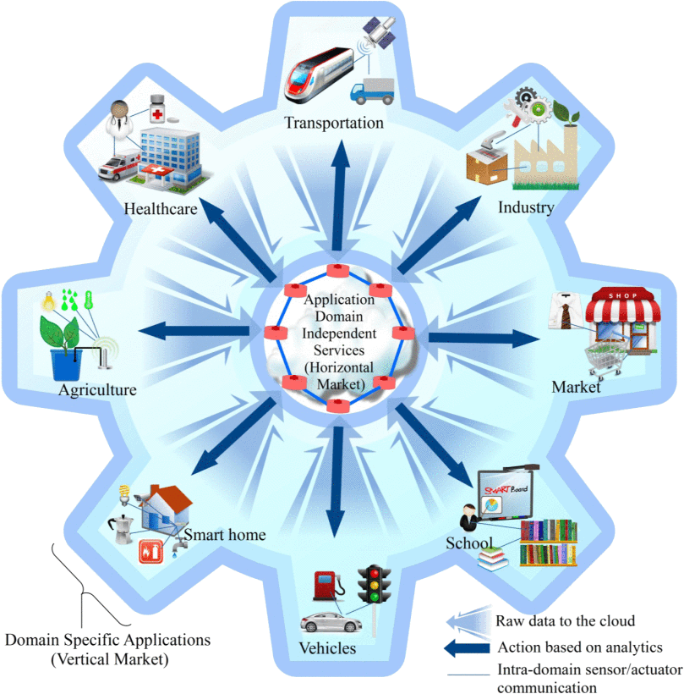
As discussed by Al-Fuqaha, the Internet of Things (IoT) lets physical items perceive, listen, reason, and execute tasks by enabling them to communicate with one another. This allows them to exchange data and coordinate actions [5]. IoT changes ordinary objects into intelligent ones by utilizing technologies like pervasive computing, embedded devices, communication methods, sensor networks, and Internet protocols. These smart objects perform specific tasks across various fields, enabling specialized applications for different industries (vertical markets). Meanwhile, services like ubiquitous computing and analytics operate across multiple sectors (horizontal markets). Figure 1 shows the IoT concept where every industry-specific application connects with general services. Within each field, sensors and actuators directly interact with one another.
Figure 2.5 Internet of Things: A Survey on Enabling Technologies, Protocols, and Applications (overall picture of IoT emphasizing the vertical markets and the horizontal integration between them)

2.2 Local Literature and Studies
2.2.1 Enhancing Home Energy Efficiency: Web and Cloud Integration for
Sustainable Electricity Monitoring
According to Aaron Coloma, the development of the web application for tracking electricity consumption among residential households provides a significant step towards encouraging sustainable practices and energy conservation procedures [6]. By giving consumers an easy-to-use platform to track their real-time electricity consumption, People are encouraged by the app to make well-informed choices on their energy usage routines. Additionally, careful thought was given to the availability, usefulness, and design of the application. Frontend frameworks and tools like Bootstrap 5. HTML and CSS were utilized to create an easy-to-use interface that works with a variety of devices. Backend frameworks and tools like Express.js, Node.js, and additionally, were utilized to enable effective user data processing and management inputs for meter reading and authentication.
Figure 2.6 Server – Side Rendering (SSR) Architecture

2.2.2 Household electric monitoring IoT system
J.B. Palomar and her team conducted a study where they designed a setup using IoT to monitor households. This system successfully identified electricity theft occurring between a household's power meter and the utility service. [7] By comparing the electricity sensor data transmitted between two points, the system could detect discrepancies. The measurements were tracked with a specially created web application, which alerted the owner via SMS whenever theft was detected. Their approach proved to be completely effective in spotting and disconnecting illegal connections.
Figure 2.7 Household electric monitoring IoT system
2.2.3 Individual Load Monitoring of Appliances for Home Energy Management System
Energy monitoring systems help people use energy efficiently. They do this by giving users information about how much electricity they are using. A study by Loyola, Joson, and Salvador in 2020 created a system to monitor energy use in homes [8]. This system used a method called intrusive load monitoring and wireless technology. The system had devices that measured energy use, small computers called Arduino Uno and Raspberry Pi, to track how much energy each appliance in a home used. These appliances were connected to the system through circuits. The data collected was sent to a platform on the internet, where users could see how much energy they were using in real-time on devices connected to the internet. The study found that monitoring energy use directly for each appliance is more accurate than other methods. This is because each appliance is connected to its monitoring device. This allows for the measurement and identification of how much energy each appliance uses. The researchers used a method called regression analysis to understand how appliances use energy. The results showed that the method
was very reliable, with correlation values ranging from 85% to 94%. Further statistical testing showed that the predicted and actual energy use values were the same, with about 99% accuracy. The study used intrusive load monitoring, energy consumption, and
wireless communication technology to achieve these results. The energy monitoring system provided users with information about their electricity consumption. However, the results of the study demonstrated the effectiveness of intrusive load monitoring in energy management.
Figure 2.8 Overall diagram of the home energy management system.

2.2.4 Development of an IoT-based water and power monitoring system for a residential building
The study by Engr. Leah Q. Santos and her team titled Development of IoT-based Water and Power Monitoring System for Residential Building was about creating a system that lets the tenants and landlords track how much electricity and water they use in real time [9]. This system connects power and water meters to cloud storage and a special Android app. With this, users can check how much power and water they are using on their smartphones from anywhere. The researchers made both the hardware and software parts, including meter designs and a mobile app. The app shows how much power and water are being used, billing details, and even sends notifications. The system is based on the Internet of Things or IoT, which is like a network of devices that can talk to each other. It helps people monitor their power and water use.
Figure 2.9 System block diagram
The study used a quantitative method to see how well the monitoring system worked. It looked at how accurate and functional the system was. The results showed that the power meter was correct about 88.82 percent of the time. The water meter was more accurate, getting it right about 98.98 percent of the time. The study used tests to compare the results from the new system to the old meters. It found that the results were basically the same, which means the new system is reliable. The monitoring system also had an Android app that worked well on different versions of Android. People who used the app thought it was reliable and easy to use. They liked it a lot. The overall rating was very positive. The monitoring system and the app were tested together. The results showed that the monitoring system was accurate and functional, and the app was a great way to use it.

2.2.5 Development of Smart Meter to Monitor Real-Time Energy Consumption for Sustainability
Smart energy meters are really helping us with our energy use. They are an improvement over the old ways of measuring energy. Nebrida et al. developed a smart meter to monitor real-time energy consumption [10]. This smart energy meter helps us see how much energy we are using in our homes right now. It gets the information it needs from the electricity in our homes. The people who made this system wanted to make it easier to get the numbers and to get them faster. They also wanted to help us use energy better. Smart energy meters are a solution to the problems we had with the old energy meters.
Figure 2.10 Component layout
The smart meter measures voltage, current, power, frequency, power factor, and energy consumption. It uses a PZEM-016 AC Energy Meter. This system provides monitoring and instant feedback to users. It helps them track their electricity consumption. They can also identify areas where they might be wasting energy Nebrida et al., 2023.
2.3 Synthesis of the Reviewed Literature & Studies
The reviewed foreign and local literature highlights the growing importance of energy monitoring systems that integrate the Internet of Things (IoT), smart sensors, and microcontrollers to improve residential electricity management. These studies collectively demonstrate how modern technologies allow users to monitor energy consumption, analyze electrical parameters, and promote efficient energy usage in households.
Foreign studies mainly focused on IoT-based electrical monitoring systems that use sensors and microcontrollers for real-time data acquisition.
- Maulida, Indrianto, and Rochmawati (2025) developed an IoT-based household power monitoring system using the ESP32 and PZEM-004T to measure electrical parameters such as voltage, current, power, and energy consumption. Similarly,
- Sofwan et al. (2025) designed an IoT monitoring system integrated with the Blynk application, enabling users to monitor power usage online and detect electricity theft through real-time data comparison.
- Prasetyo (2025) further expanded this concept by integrating a system that measures multiple electrical parameters, including voltage, current, frequency, and power factor, while allowing remote control of appliances through a web interface.
These studies demonstrate that IoT technologies can effectively support real-time monitoring and remote management of electrical loads. In addition, foundational studies on IoT provided the theoretical framework for these systems.
- Luigi Atzori (2010) discussed how IoT enables interconnected devices within smart homes, allowing appliances to communicate and operate efficiently. Likewise,
- Ala Al-Fuqaha (2015) explained the enabling technologies, communication protocols, and sensor networks that make IoT-based applications possible across different industries.
On the local level, several studies emphasized the practical implementation of monitoring systems in residential environments.
- K.A. Coloma (2024) developed a web- and cloud-based electricity monitoring application that allows users to track their real-time energy consumption through an accessible interface. Similarly,
- J.B. Palomar (2025) created an IoT-based household monitoring system capable of detecting electricity theft by comparing power data between two measurement points and sending alerts through a web platform. Another study by
- Loyola, Joson, and Salvador (2020) implemented an intrusive load monitoring system using Arduino Uno and Raspberry Pi to measure the energy consumption of individual appliances with high accuracy. Furthermore,
- Leah Q. Santos (2021) developed an IoT-based water and power monitoring system that integrates cloud storage and a mobile application for real-time monitoring. Lastly,
- Nebrida et al. (2023) introduced a smart meter using the PZEM-016 AC Energy Meter to measure electrical parameters and provide instant feedback on electricity usage.
Overall, the reviewed studies reveal that IoT-based monitoring systems, smart meters, and load monitoring technologies significantly contribute to improving energy efficiency and providing users with real-time electricity consumption data. While foreign studies focus on system design, sensor integration, and IoT architecture, local studies emphasize real-world applications and user accessibility. However, there remains a need to further develop systems that combine cost-effective hardware, accurate load monitoring, and user-friendly interfaces for residential energy management. Therefore, the present study aims to design and develop a load monitoring device for residential appliances while providing real-time monitoring through IoT technology.

Chapter 3
RESEARCH METHODOLOGY

3.1 Project Development Model
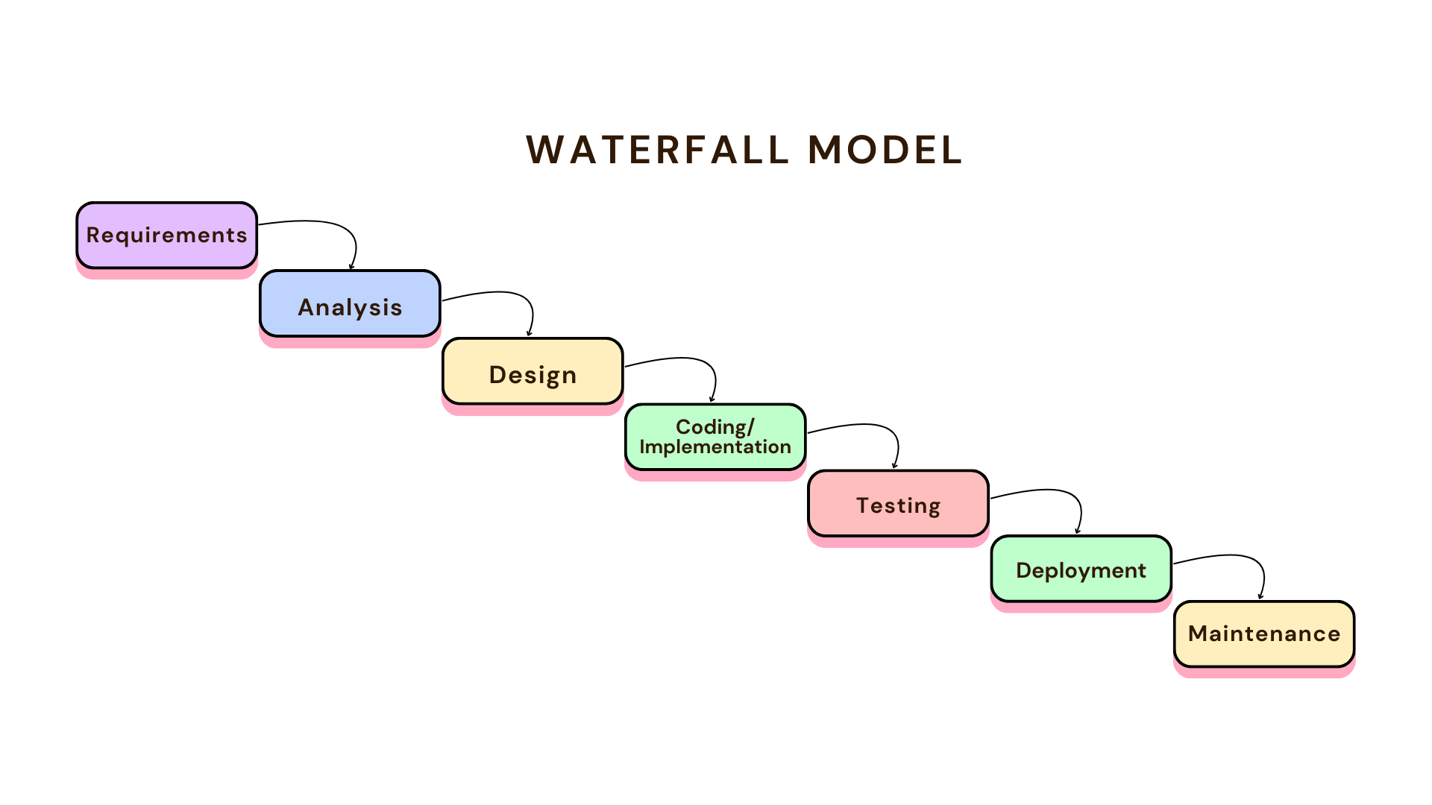
This study used the Waterfall Development Model. The project was divided into 7 phases. The approach is frequently used in many engineering and technology-driven initiatives, such as software development, industrial manufacturing, information technology, and electrical system design. Because each step in the Waterfall process depends on the successful completion and recorded output of the one before it, the workflow is structured and sequential, with system requirements, design, implementation, testing, and deployment all occurring linearly.

Figure 3.1 Waterfall Model
3.2 Project Design
The presentation layer, which includes the mobile application interface, the application layer, which handles server-side processing and control logic, and the data layer, which uses a MySQL database for structured data storage, make up the project's three-layer system architecture. This architecture is intended to facilitate dependable system operation, effective data handling, and an intuitive user interface for control and monitoring.

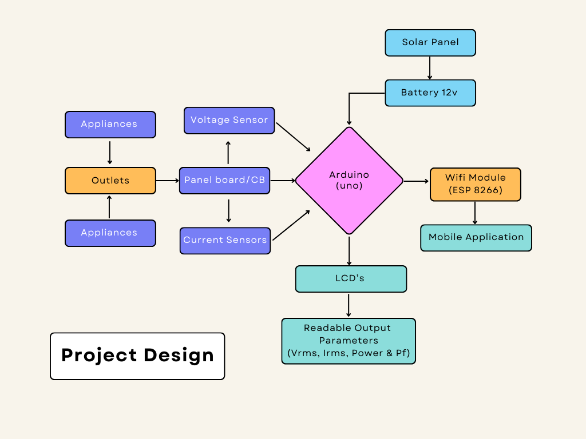

Figure 3.2 Project Design Block Diagram
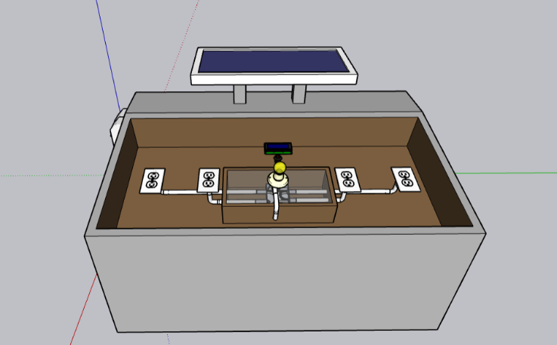
Figure 3.3 3D Front of the Project Design
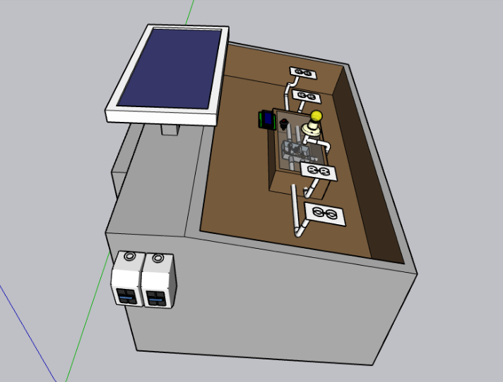
Figure 3.4 3D left Side of the Project Design
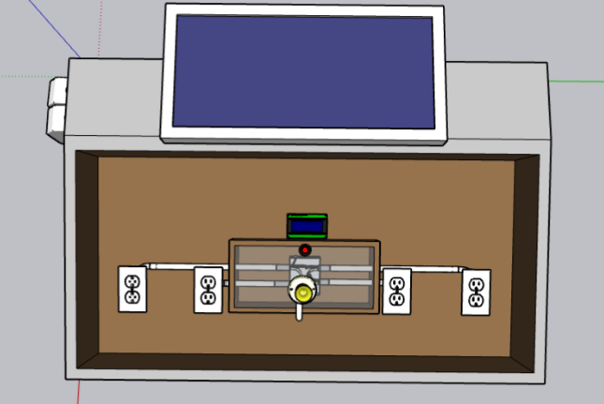
Figure 3.5 3D Upper Side of the Project Design
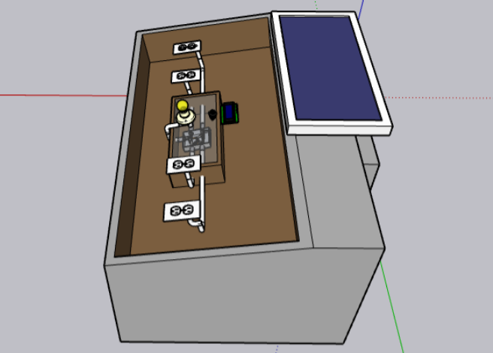
Figure 3.6 3D right Side of the Project Design

3.3 Operation Flow of the Proposed System
The user logs into the application→selects a user room → system retrieves data from the database → system calculate the estimated electric monthly due → user confirmed the displayed data from the application.
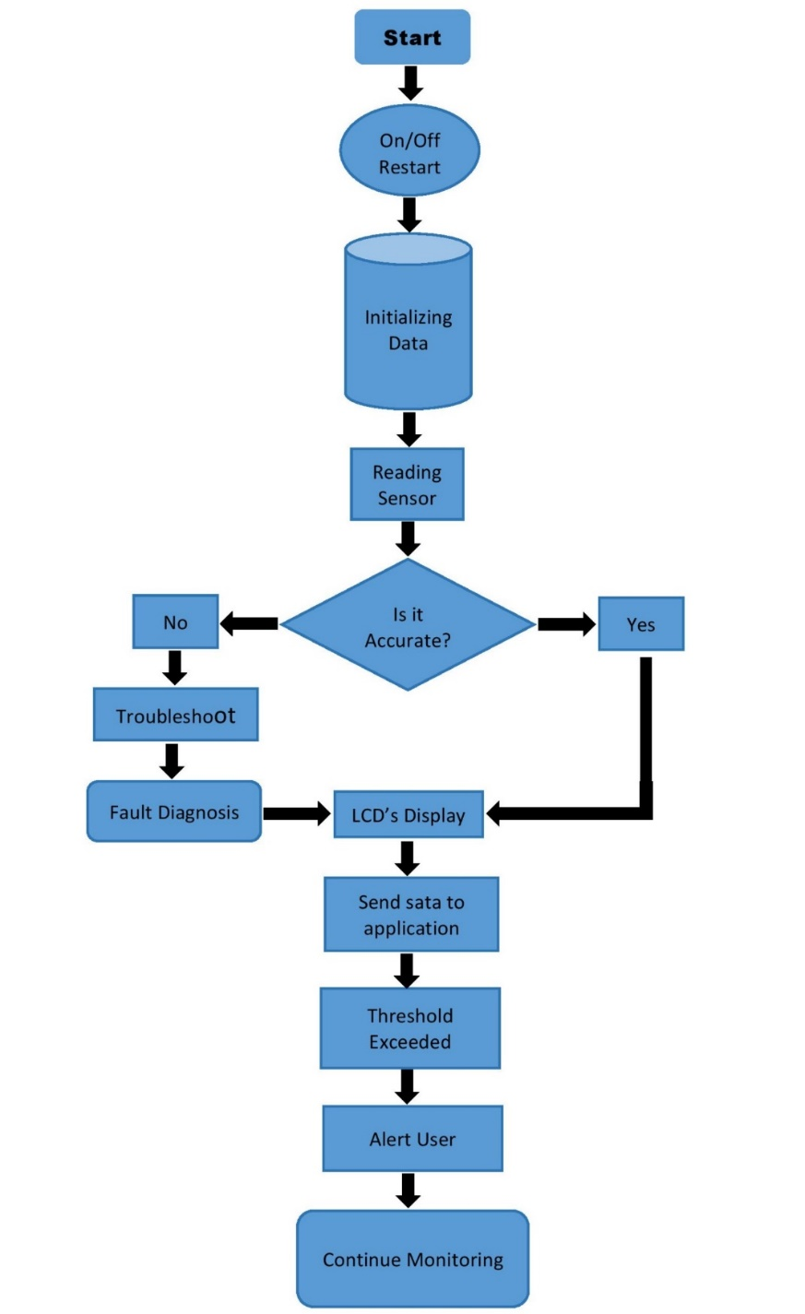

Figure 3.7 System Flowchart
3.4 Description & Specification of materials Used
Hardware:
- Microcontroller (ESP 32)
- Sensors
(Voltage and Current sensor)
- Wi-Fi module (ESP8266)
- Breadboard (Full size)
- Electronic wires (22 AWG to 24 AWG Stranded Wire)
- Electrical Wires THHN, AWG (#12 #14 #10)
- Solar panel (100w)
- Battery (12v – 24v)
- Power Supply (5v output)
- Circuit Breaker (60A Main 30A Per Room)
- Marine board (2 x 4ft by 1’’ thick)
- Convenient outlets (2 gang outlets)
- LCD I2C display (20 x 7)
- Junction box
- Molding (50x 50mm)
Software:
- Wokwi (Website)
- Arduino IDE (C++)

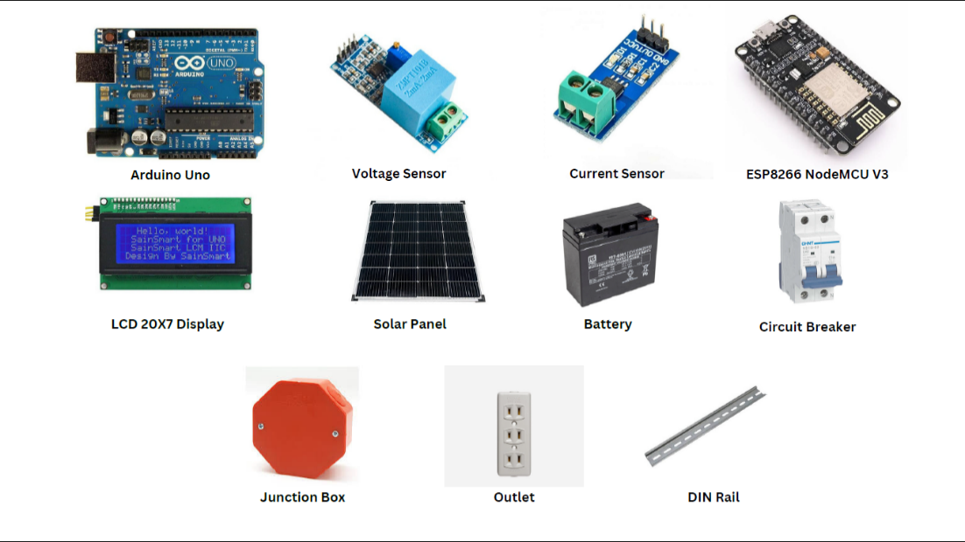
FIGURE 3.8
3.5 Research Method Used
The study assessed user satisfaction with the Non-Intrusive Load Monitoring app using both the experimental and qualitative research methods. Selected respondents were surveyed and interviewed to gather data. This identifies the method used to gather and analyze data.
Methods:
- Experimental Method – tests cause-and-effect relationships.
- Qualitative Method – focuses on opinions, behaviors, and experiences.

3.6 Description of Respondents
The study will be conducted in a boarding house consisting of 25 rooms located in Sto. Macanhan, Carmen, Cagayan de Oro City. The population frame included all boarders residing in the said boarding house. A combination of purposive and quota sampling was employed to select 25 respondents. The participants were chosen based on specific criteria, particularly they will be the prior for experiencing and familiarity with the Load Monitoring system, ensuring that they could provide relevant and reliable feedback for the evaluation of the development of the Load Monitoring system.
3.7 Statistical Analysis of Data
The Likert scale responses were analyzed using the weighted mean to determine the level of user satisfaction. Furthermore, an independent samples t-test was employed to compare the performance of the traditional process and the developed system in order to determine whether a significant difference existed between the two approaches.
3.8 Research Instruments Used
A eight-item Likert-scale questionnaire was used to evaluate the system’s usability, efficiency, accuracy, and reliability, complemented by an interview guide for detailed feedback.
3.9 Data Gathering Procedure
- Preparation: The researcher created and validated the questionnaire with the help of experts.
- Distribution: The questionnaire was distributed to respondents through Google Forms.
- Collection: Data responses were automatically recorded in Google Sheets.
- Processing: The data were encoded, organized, and checked for errors.
- Analysis: The researcher used statistical tools to analyze the responses,

CHAPTER 4
PRESENTATION, ANALYSES, AND INTERPRETATION OF DATA

4.1 Development and Implementation of the Load Monitoring Device
This chapter presents the results and discussion of the developed Load Monitoring Device for Residential Appliances. It focuses on the implementation and evaluation of the developed system based on the objectives of the study. The evaluation covers the system's usability, accuracy, reliability, and efficiency. The chapter also presents the comparison between the traditional monitoring process and the developed load monitoring system.
The developed system was designed to provide real-time monitoring of electrical parameters associated with residential appliances. The system utilizes sensors to acquire electrical data, an ESP32 microcontroller to process the collected information, and Internet of Things (IoT) connectivity to allow users to access monitoring information. The developed device provides electrical parameters such as voltage RMS (V), current RMS (A), power factor (Pf), instantaneous power (W), and instantaneous apparent power (VA).

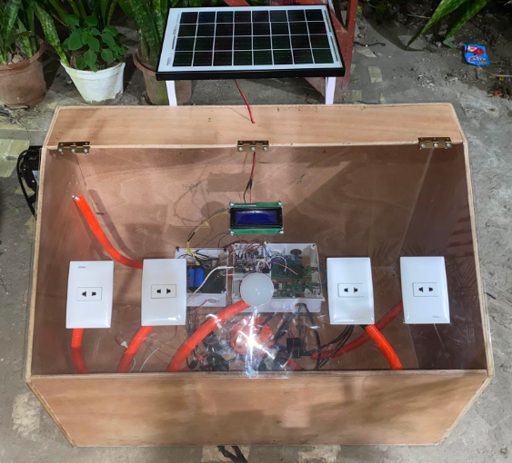
Figure 4.1 Completed Prototype of the developed Load Monitoring Device
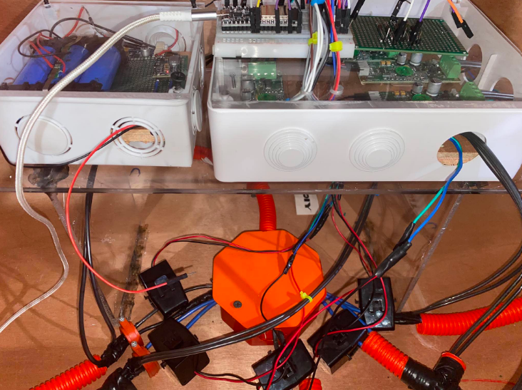

Figure 4.2 Wiring and Control Components and other Major Components
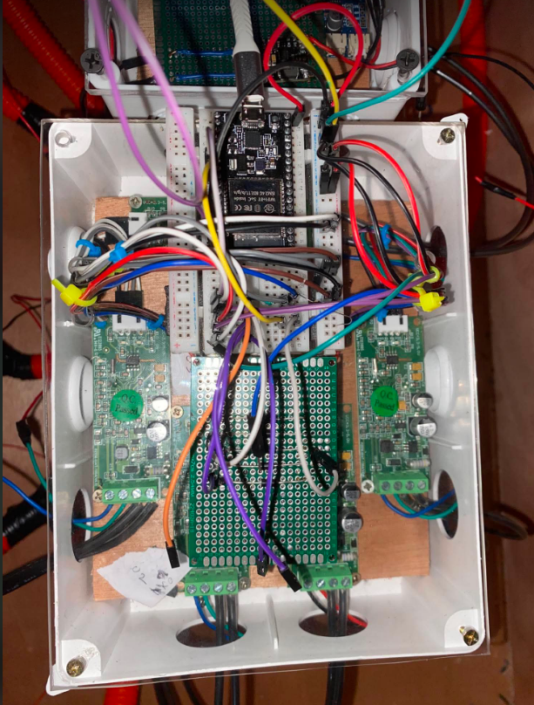
Figure 4.3 Upper View of Microcontroller

EVALUATION CRITERIA | NUMBER OF ITEMS | WEIGHTED MEAN | VERBAL INTERPRETATION
Usability | 8 | [TBD] | [TBD]
Accuracy | 8 | [TBD] | [TBD]
Reliability | 8 | [TBD] | [TBD]
Efficiency | 8 | [TBD] | [TBD]
Overall Mean | 32 | [TBD] | [TBD]

Table 4.1 Evaluation Criteria for the Developed Load Monitoring Device

4.2 Evaluation of the Usability of the Developed System
The usability of the developed Load Monitoring Device was evaluated based on the respondents’ assessment of the system’s ease of operation, clarity of displayed information, and convenience in monitoring residential electrical loads. The respondents evaluated the developed system using the prepared Likert-scale questionnaire. The weighted mean was used to determine the overall assessment of the respondents, with the corresponding verbal interpretation based on the established Likert scale.

NO. | INDICATORS | WEIGHTED MEAN | VERBAL INTERPRETATION
1 | The Load Monitoring Devices is easy to use. | [TBD] | [TBD]
2 | The displayed electrical information is easy to understand. | [TBD] | [TBD]
3 | The device is easy to operate without extensive technical knowledge. | [TBD] | [TBD]
4 | The monitoring interface is clear and understandable. | [TBD] | [TBD]
5 | The device provides the electrical information needed for monitoring household appliances. | [TBD] | [TBD]
6 | The process of monitoring an appliance using the device is simple. | [TBD] | [TBD]
7 | The device makes monitoring household electricity consumption more convenient. | [TBD] | [TBD]
8 | The information displayed by the system is easy to interpret. | [TBD] | [TBD]
 | OVERALL MEAN

Table 4.2 Evaluation of the Developed Load Monitoring Device in Terms of Usability

4.3 Evaluation of the Accuracy of the Developed System
The accuracy of the developed Load Monitoring Device was evaluated to determine the respondents’ assessment of the system’s ability to provide accurate electrical monitoring information. The evaluation was conducted using an eight-item Likert-scale questionnaire. The responses were analyzed using the weighted mean and interpreted according to the established Likert scale. In addition to the questionnaire evaluation, objective accuracy testing was conducted by comparing the readings obtained from the developed system with the corresponding readings from the selected reference measuring instrument.

NO. | INDICATORS | WEIGHTED MEAN | VERBAL INTERPRETATION
1 | The developed system provides accurate voltage measurements. | [TBD] | [TBD]
2 | The developed system provides accurate current measurements. | [TBD] | [TBD]
3 | The developed system provides accurate power measurements. | [TBD] | [TBD]
4 | The developed system provides accurate power factor measurements. | [TBD] | [TBD]
5 | The developed system provides accurate frequency measurements. | [TBD] | [TBD]
6 | The developed system provides accurate energy consumption measurements.. | [TBD] | [TBD]
7 | The electrical information displayed by the system is consistent with the actual load condition. | [TBD] | [TBD]
8 | The developed system provides reliable electrical information for monitoring residential loads. | [TBD] | [TBD]
 | OVERALL MEAN

Table 4.3 Evaluation of the Developed Load Monitoring Device in Terms of Accuracy

Table 4.3 presents the respondents’ evaluation of the developed Load Monitoring Device in terms of accuracy. The weighted mean for each indicator and the overall mean will be used to determine the respondents’ assessment of the accuracy of the developed system. The corresponding verbal interpretations will be determined using the established Likert scale after the completion of data gathering.

4.3.1 Objective Accuracy Testing
In addition to the questionnaire evaluation, the accuracy of the developed system was determined through actual measurement testing. The readings obtained from the developed system were compared with the readings from the selected reference measuring instrument. The comparison was used to determine the measurement accuracy of the developed system based on the selected electrical parameters.

ELECTRICAL PARAMATER | REFERENCE READING | DEVELOPED SYSTEM READING | DIFFERENCE | PERCENTAGE ERROR
Voltage (V) | [TBD] | [TBD] | [TBD] | [TBD]
Current (A) | [TBD] | [TBD] | [TBD] | [TBD]
Power (W) | [TBD] | [TBD] | [TBD] | [TBD]
Energy (kWh) | [TBD] | [TBD] | [TBD] | [TBD]
Power Factor (PF) | [TBD] | [TBD] | [TBD] | [TBD]
Frequency (Hz) | [TBD] | [TBD] | [TBD] | [TBD]

Table 4.4 Comparison Between Reference Measurement and Developed System

Table 4.4 presents the comparison between the measurements obtained from the selected reference measuring instrument and the developed Load Monitoring Device. The comparison covers the electrical parameters monitored by the developed system, including voltage, current, power, power factor, frequency, and energy consumption. The difference between the reference measurements and the readings obtained from the developed system will be used to determine the measurement accuracy of the developed system.

4.4 Evaluation of the Reliability of the Developed System
The reliability of the developed Load Monitoring Device was evaluated to determine its consistency and dependability during operation. The respondents assessed the developed system based on its ability to operate consistently, provide stable monitoring results, and perform its intended functions. The evaluation was conducted using the Likert-scale questionnaire, and the responses were analyzed using the weighted mean. The corresponding verbal interpretation will be used to describe the respondents’ assessment of the reliability of the developed system.

NO. | INDICATORS | WEIGHTED MEAN | VERBAL INTERPRETATION
1 | The device operates properly during normal use. | [TBD] | [TBD]
2 | The device provides readings consistently during repeated use. | [TBD] | [TBD]
3 | The monitoring system responds properly when an appliance is turned on or off. | [TBD] | [TBD]
4 | The system maintains stable operation during the monitoring process. | [TBD] | [TBD]
5 | The device can continuously monitor electrical parameters without frequent interruptions. | [TBD] | [TBD]
6 | The system provides dependable information during appliance monitoring. | [TBD] | [TBD]
7 | The device performs its intended monitoring functions consistently | [TBD] | [TBD]
8 | The device can be relied upon for monitoring household electrical consumption. | [TBD] | [TBD]
 | OVERALL MEAN

Table 4.5 Evaluation of the Developed Load Monitoring Device in Terms of Reliability

The results presented in Table 4.5 will be used to determine the respondents’ assessment of the reliability of the developed Load Monitoring Device. The weighted mean for each indicator and the overall mean will be interpreted using the established Likert scale. The final results and discussion will be presented after the completion of the questionnaire administration and data analysis.

4.5 Evaluation of the Efficiency of the Developed System
The efficiency of the developed Load Monitoring Device was evaluated to determine its ability to perform its intended monitoring functions effectively while providing electrical information to the users. The respondents assessed the developed system based on its ability to provide monitoring information efficiently, respond appropriately during operation, and support convenient monitoring of residential electrical loads. The evaluation was conducted using the eight-item Likert-scale questionnaire, and the responses were analyzed using the weighted mean. The corresponding verbal interpretation was used to describe the respondents’ assessment of the efficiency of the developed system.

NO. | INDICATORS | WEIGHTED MEAN | VERBAL INTERPRETATION
1 | The device provides electrical readings in a timely manner. | [TBD] | [TBD]
2 | The device allows electrical consumption to be monitored efficiently. | [TBD] | [TBD]
3 | The system reduces the time needed to obtain electrical consumption information. | [TBD] | [TBD]
4 | The device provides useful electrical information without unnecessary steps. | [TBD] | [TBD]
5 | The system is efficient in monitoring residential appliances. | [TBD] | [TBD]
6 | Real-time monitoring improves the efficiency of checking electricity consumption. | [TBD] | [TBD]
7 | The device helps users identify appliance electricity consumption efficiently. | [TBD] | [TBD]
8 | The developed device provides an efficient way of monitoring hou.6sehold electricity consumption. | [TBD] | [TBD]
 | OVERALL MEAN

Table 4.6 Evaluation of the Developed Load Monitoring Device in Terms of Efficiency

The results presented in Table 4.6 will be used to determine the respondents’ assessment of the efficiency of the developed Load Monitoring Device. The weighted mean for each indicator and the overall mean will be interpreted using the established Likert scale. The final results and discussion will be presented after the completion of the questionnaire administration and data analysis.

4.6 Likert Scale Interpretation
The responses of the respondents were evaluated using a five-point Likert scale. The weighted mean was used to determine the respondents’ assessment of the developed Load Monitoring Device in terms of usability, accuracy, reliability, and efficiency. Each computed weighted mean was interpreted according to the corresponding numerical range and verbal interpretation presented in Table 4.7.

WEIGHTED MEAN RANGE | VERBAL INTERPRETATION
4.2-5.00 | Strongly Agree
3.41-4.20 | Agree
2.61-3.40 | Neutral
1.81-2.60 | Disagree
1.00-1.80 | Strongly Disagree

Table 4.7 Likert Scale and Verbal Interpretation
The verbal interpretations were used to describe the respondents’ level of agreement with each statement. The same interpretation scale was applied to the weighted mean obtained for each indicator and the overall mean for usability, accuracy, reliability, and efficiency.

4.7 Overall Evaluation of the Developed Load Monitoring Device
The overall evaluation of the developed Load Monitoring Device will be determined based on the respondents’ assessments in terms of usability, accuracy, reliability, and efficiency. The weighted mean obtained for each evaluation criterion was used to determine the overall assessment of the developed system. The overall mean was then computed to provide a general evaluation of the developed Load Monitoring Device. The results were interpreted using the Likert scale and verbal interpretation presented in Table 4.7.

Evaluation Criteria | Weighted Mean | Verbal Interpretation
Usability | [TBD] | [TBD]
Accuracy | [TBD] | [TBD]
Reliability | [TBD] | [TBD]
Efficiency | [TBD] | [TBD]
Overall mean | [TBD] | [TBD]

Table 4.8 Overall Evaluation of the Developed Load Monitoring Device

4.8 Comparison Between the Traditional Monitoring Method and the Developed System
The developed Load Monitoring Device was compared with the traditional monitoring method to determine the differences in the process of monitoring residential electrical loads. The comparison focused on the monitoring process, availability of electrical information, convenience, and accessibility of the measured parameters. The developed system utilizes an ESP32-based monitoring system with electrical sensing and display capabilities, while the traditional method relies on conventional procedures for obtaining electrical measurements. The results of the comparison will be presented after the completion of the data gathering and testing procedures.
Evaluation Measure | Traditional Method Mean | Developed System Mean | t-value | p-value | Decision | Remarks
Monitoring Performance | [TBD] | [TBD] | [TBD] | [TBD] | [TBD] | [TBD]
Accuracy | [TBD] | [TBD] | [TBD] | [TBD] | [TBD] | [TBD]

Table 4.9 Comparison of the Traditional Monitoring Method and the Developed System

The traditional monitoring method and the developed Load Monitoring Device were compared to determine whether a significant difference exists between the two approaches. The comparison focused on monitoring performance and accuracy. An independent-samples t-test will be used to determine the significance of the difference between the mean results of the traditional monitoring method and the developed system at a significance level of 0.05. The results of the comparison will be presented after the completion of data gathering and statistical analysis.

4.9 Challenges Encountered During the Implementation
The study also sought to determine the challenges encountered during the implementation and use of the developed Load Monitoring Device. The identified challenges may include issues related to system connectivity, sensor readings, power supply, hardware components, software or programming, and other operational concerns encountered during the development and testing of the system. The frequency and percentage of responses will be used to summarize the challenges reported by the respondents or identified during the implementation. The results will be presented after the completion of the data gathering and evaluation procedures.

Challenge | Frequency | Percentage
Connectivity issues | [TBD] | [TBD]%
Sensor reading fluctuation | [TBD] | [TBD]%
Difficulty in operating the system | [TBD] | [TBD]%
Power interruption | [TBD] | [TBD]%
Application/interface issues | [TBD] | [TBD]%
Other identified challenges | [TBD] | [TBD]%

Table 4.10 Challenges Encountered During the Use of the Developed System
The frequency and percentage results in Table 4.10 will be used to identify the most commonly encountered challenges during the implementation and use of the developed Load Monitoring Device. The findings will provide a basis for identifying areas of the system that may require improvement. The final discussion will be presented after the completion of data gathering and analysis.

CHAPTER 5
SUMMARY, CONCLUSION AND RECOMMENDATIONS
5.1 Summary of Findings
This study focused on the design, development, and evaluation of an IoT-Based Load Monitoring Device for Residential Appliances. The developed system was designed to monitor selected electrical parameters of residential appliances and provide users with information regarding electrical consumption through an IoT-based monitoring platform. The study evaluated the developed system in terms of usability, accuracy, reliability, and efficiency, compared the traditional monitoring method with the developed system, and identified challenges encountered during implementation.
The summary of findings is presented according to the objectives of the study.
1. Development of the IoT-Based Load Monitoring Device
The study developed an IoT-based Load Monitoring Device for residential appliances using an ESP32 microcontroller, electrical sensors, Internet connectivity, and a monitoring interface. The prototype was designed to acquire and process electrical measurements and present the monitored information to the user.
The system was developed following the Waterfall Model, which consisted of sequential stages including requirements analysis, system design, implementation, testing, deployment, and maintenance.
Finding: The developed prototype [TBD – describe the final working condition and results of prototype testing].
2. Monitoring of Electrical Parameters and Energy Consumption
The developed system was designed to monitor the electrical parameters of residential appliances, including voltage, current, power, power factor, frequency, and energy consumption. These measurements provide users with information that can help them monitor their electrical usage and become more aware of their energy consumption and potential electricity costs.
Finding: The system recorded [TBD] for voltage, [TBD] for current, [TBD] for power, [TBD] for power factor, [TBD] for frequency, and [TBD] for energy consumption during the testing period.

3. Development of the Mobile Application for Real-Time Monitoring
The study developed an IoT-based mobile monitoring interface that allows users to access information regarding the electrical consumption of connected residential appliances. The system was designed to provide real-time monitoring information and make electrical data more accessible to users.
Finding: The mobile application achieved [TBD] in terms of its ability to display and provide real-time electrical monitoring information.

4. Evaluation of the Developed System
The developed Load Monitoring Device was evaluated in terms of usability, accuracy, reliability, and efficiency using an eight-item questionnaire for each criterion. The responses were analyzed using the weighted mean and interpreted using the established five-point Likert scale.
4.1 Usability
The usability of the developed system was evaluated based on the respondents' assessment of its ease of use, operation, and understanding.
Finding: The developed system obtained a weighted mean of [TBD], with a verbal interpretation of [TBD] in terms of usability.
4.2 Accuracy
The accuracy of the developed system was evaluated through the respondents' assessment and objective measurement testing. The objective accuracy testing compared the readings obtained from the developed system with the corresponding readings from the selected reference measuring instrument.
The electrical parameters considered in the accuracy testing included voltage, current, power, power factor, frequency, and energy consumption.
Finding: The developed system obtained a weighted mean of [TBD], with a verbal interpretation of [TBD] in the questionnaire evaluation. The objective accuracy testing resulted in an accuracy of [TBD]%.
4.3 Reliability
The reliability of the developed system was evaluated based on the respondents' assessment of its consistency, dependability, and ability to perform its intended monitoring functions.
Finding: The developed system obtained a weighted mean of [TBD], with a verbal interpretation of [TBD] in terms of reliability.

4.4 Efficiency
The efficiency of the developed system was evaluated based on the respondents' assessment of its ability to perform its monitoring functions effectively and provide electrical information conveniently.
Finding: The developed system obtained a weighted mean of [TBD], with a verbal interpretation of [TBD] in terms of efficiency.

Overall Evaluation
Based on the four evaluation criteria, the developed Load Monitoring Device obtained an overall weighted mean of [TBD], with a verbal interpretation of [TBD].

5. Comparison Between the Traditional Monitoring Method and the Developed System
The study compared the traditional monitoring method and the developed Load Monitoring Device in terms of monitoring performance and accuracy. An independent-samples t-test was used to determine whether there was a significant difference between the two methods at a 0.05 level of significance.
Finding: The traditional monitoring method obtained a mean of [TBD], while the developed system obtained a mean of [TBD] for monitoring performance. The computed t-value was [TBD] and the p-value was [TBD].
For accuracy, the traditional monitoring method obtained a mean of [TBD], while the developed system obtained a mean of [TBD]. The computed t-value was [TBD] and the p-value was [TBD].
Based on the statistical results, the null hypothesis was [TBD – rejected/failed to be rejected].

6. Backup Power Source
The developed system incorporated a backup power source intended to support the operation of the monitoring device during power interruptions. The backup power system was designed to provide an alternative source of power for continued operation of the monitoring device.
Finding: During backup-power testing, the system operated for [TBD] under the tested conditions, with the monitoring functions [TBD].

7. Challenges Encountered During Implementation
The study identified the challenges encountered during the implementation and use of the developed Load Monitoring Device. The challenges were summarized using frequency and percentage to determine the most commonly encountered issues.
Finding: The most frequently encountered challenge was [TBD], with a frequency of [TBD] and a percentage of [TBD]%.
Other challenges identified included [TBD], [TBD], and [TBD].

5.2 Conclusions
Based on the findings of the study, the following conclusions will be drawn:
1. Development of the System
The study successfully developed an IoT-based Load Monitoring Device designed to monitor electrical parameters of residential appliances and provide accessible electrical consumption information to users.
Final conclusion: [TBD – finalize after prototype testing.]
2. Electrical Parameter and Energy Monitoring
The developed system was capable of monitoring voltage, current, power, power factor, frequency, and energy consumption of residential loads.
Final conclusion: [TBD – based on actual testing results.]
3. Mobile Application
The developed mobile monitoring application provided users with access to electrical monitoring information and supported real-time monitoring of connected residential loads.
Final conclusion: [TBD – based on application testing.]
4. System Evaluation
The developed system was evaluated in terms of usability, accuracy, reliability, and efficiency. The results of the questionnaire and objective accuracy testing provided the basis for determining the overall performance of the developed system.
Final conclusion: [TBD – based on the four weighted means and objective accuracy results.]
5. Traditional Monitoring Method and Developed System
The statistical comparison between the traditional monitoring method and the developed system determined whether a significant difference existed between the two approaches.
Final conclusion: [TBD – based on the t-test and p-value.]
6. Backup Power
The developed backup power source provided an alternative source of power intended to maintain the operation of the monitoring system during power interruptions.
Final conclusion: [TBD – based on backup-power testing.]
7. Implementation Challenges
The study identified challenges encountered during the implementation and use of the developed system. These findings provided information regarding areas that may require improvement in future versions of the system.
Final conclusion: [TBD – based on the frequency and percentage results.]

5.3 Recommendations
Based on the objectives and the anticipated findings of the study, the following recommendations are proposed:
- System Improvement. Future researchers should improve the hardware and software components of the Load Monitoring Device to enhance its usability, accuracy, reliability, and efficiency.
- Accuracy Improvement. Further testing should be conducted using reliable reference measuring instruments and different types and levels of residential loads to further validate the accuracy of the developed system.
- Extended Monitoring. Future studies should conduct longer-term monitoring to evaluate the system's performance under different operating conditions and provide more comprehensive daily, weekly, and monthly energy-consumption data.
- Mobile Application Enhancement. The mobile application may be improved by adding historical energy-consumption records, graphical presentations, estimated electricity costs, notifications, and other features that can help users better understand their electrical consumption.
- Internet Connectivity. Future versions of the system should improve connectivity and data transmission to minimize interruptions and delays in real-time monitoring.
- Backup Power Improvement. The backup power system should be further improved by considering greater battery capacity, improved charging methods, and better energy-management strategies to extend operating time during power interruptions.
- Accuracy Across Different Loads. Future researchers should test the system using a wider range of residential appliances and different load conditions to determine its performance under various operating conditions.
- Addressing Implementation Challenges. The challenges identified during implementation should be addressed in future versions of the system, particularly issues related to connectivity, sensor readings, power supply, hardware, software, and user operation.
- Future Research. Future researchers may conduct the study with a larger number of respondents and in different residential settings to further validate the effectiveness and applicability of the developed Load Monitoring Device.

REFERENCES
[1] Maulida, Indrianto, and Rochmawati, “IoT-Based Electrical Power Consumption Monitoring System in Households Using ESP32 and PZEM 004T.” Journal of Brilliance: Research on Artificial Intelligence, Vol. 5, No. 2, Pp. 1077 – 1081, November 2025.
[2] Agus Sofwan, Abdullah Multi, Mohammad Azli, and Nana Sujana, “Design of Control and Monitoring System for Electrical Power on kWh Meter Based on Internet of Things (IoT),” International Journal of Advanced Multidisciplinary, Vol. 4, No. 3, Pp. 417 – 429, December 2025.
[3] Yuli Prasetyo, “Integrated IoT System for Real-Time Electrical Load Monitoring,” Journal Geuthee of Engineering and Energy (JOGE), Vol. 4, No. 1, pp. 17 – 23, May 2025
[4] Atzori et al, “The Internet of Things: A survey,” Italy: Computer Networks, 2010.
[5] A. Al-Fuqaha, “Internet of Things: A Survey on Enabling Technologies, Protocols, and Applications,” IEEE Communications Surveys & Tutorials, 2015.
[6] K.A. Coloma, “Enhancing Home Energy Efficiency: Web and Cloud Integration for Sustainable Electricity Monitoring,” M.S. Thesis, Ateneo de Manila University, Quezon City, 2024
[7] J.B. Palomar., “Household electric monitoring IoT system,” Indonesian Journal of Electrical Engineering and Computer Science Vol. 40, No. 1, pp. 85~92, October 2025.
[8] Loyola, Joson, and Salvador, “Individual Load Monitoring of Appliances for Home Energy Management System,” M.S. Thesis, Electrical Engineering, Malayan Colleges Laguna, Cabuyao City, 2020
[9] L.Q. Santos, “Development of an IoT-based water and power monitoring system for a residential building,” M.S. Thesis, Department of Engineering, Lyceum of the Philippines University-Cavite, 2021
[10] Nebrida et al, “Development of Smart Meter to Monitor Real-Time Energy Consumption for Sustainability,” International Journal of Sustainable Construction Engineering and Technology Vol. 14 NO. 4 (2023) 28-39, 31 May 2023.

GANTT CHART
